EM Customer Inquiry SOP

This section's functionality is to capture all the customer inquiries that do not fall under the Exception types to be resolved between the different depts. This section is for the inquiries to be handled within Customer Services dept., a channel for CSRs to escalate issues to their supervisors, a platform to keep track of all the customer service escalations between CSRs and Sups.
The website address:
https://exceptions.oghq.ca/

The section of Customer Inquiry includes the following two menu bars:
1) Distributor's dashboard: it works the same as Transaction Dashboard. Only difference here is, there are two search fields: Distributor ID and Dist’s name.
2) Inquiries Worklist: it works the same as Worklist. Difference here is - there is no ticket flow across departments. Only CSR and CSR Lead create and see these tickets. Depending on status, tickets will go to respective tabs in this worklist - Open, In Progress, Pending, and Closed.
Additional flag in this worklist is ESCALATION.
How to create tickets:

- Go to Distributor’s Dashboard, enter Distributor (or Customer) ID# or Name and search.
Not in system button will generate tickets for potential customers that are not registered distributors and are not in the system.

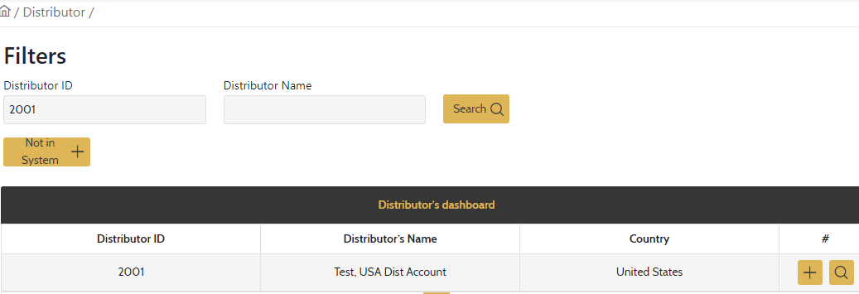

- Press + button will generate ticket creation and lead to the following page.

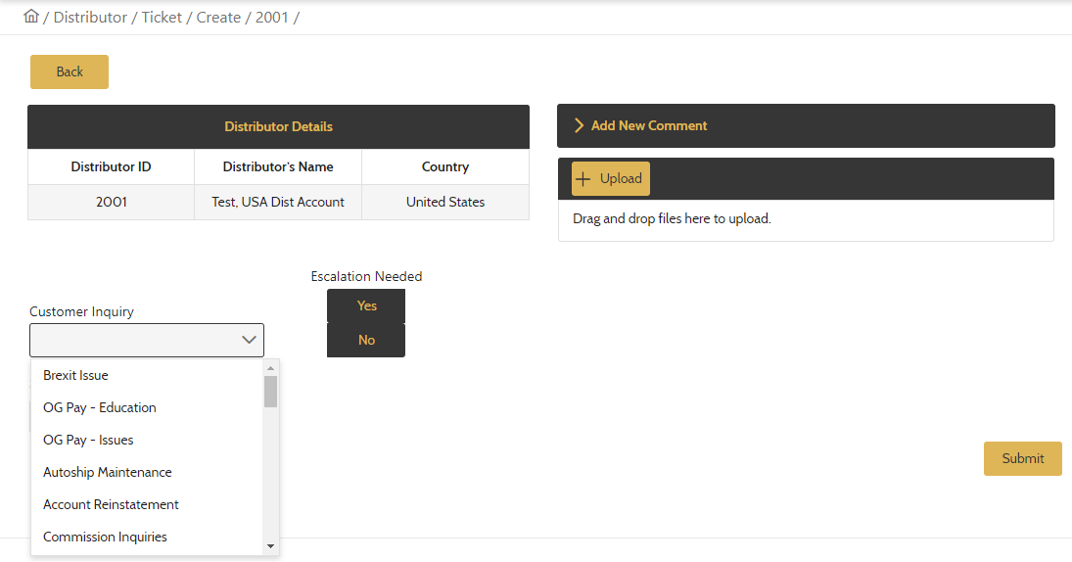

- Select the type of Inquiries from the drop-down box. If the subject is not listed, select “Other” at the bottom of drop-down and write down the details in the field below. Click on Yes under “Escalation Needed”, and set the Due Date. Users can always add comments or upload files when it is necessary. Keep the ticket status Open, then click the Submit button.

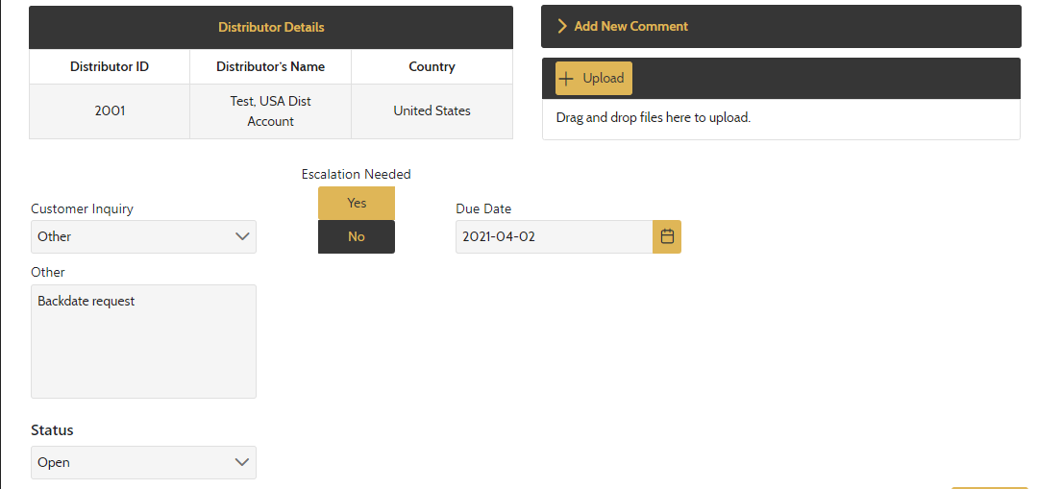

Where to review and process the ticket:

- Go to Inquiries Worklist, filter the tickets by the call centers by searching the user’s prefix, for example “CA-“, all the tickets created by CA users will be displayed. Supervisors should pay attention to Inquiry Type, by whom the ticket was created, and the Due Date. The users (both CSR and Sups) can click on to edit the ticket, such as adding the new comments or changing the ticket status.

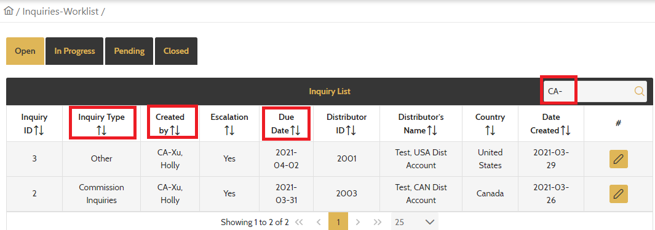

Key notes:

- Both CSR and CSR Lead users have exactly same access to EM Customer Inquiries. However, normally CSRs are to create tickets, and Sups review and process the tickets that are escalated.
- Due date can be set for the same day, or within 1-3 business days depending on urgency of issues. It is important that CSRs set the ticket’s due date properly and Sups check the open tickets diligently before the due date.
- The system give CSR users the options to escalate the issue, or not to escalate but still create the ticket for own record. To keep the system clean, we recommend that we use this function for internal escalations only.
- The list of Customer Inquiries is to be provided in a separate excel file. This list is not permanent and will be reviewed and edited periodically.

